**WDD 230 – Winter 2021 Final Project -** **Charleson Otubu**

Title: Abuja Chamber of Commerce and Industries

Website Planning Document

**Site Title**: Abuja Chamber of Commerce

**Site Purpose**:

*Provide a brief statement about the purpose of the website drawing upon the client's functional specifications, the industry, and any fictitious but viable goals that you deem to be reasonable.*

The overall goal of the website is to promote the business interests of the members of the abuja Chamber of Commerce and promote Abuja, attracting additional business, investments and people to the federal capital of Nigeria.

1. To promote the development business of members in all economic spheres including Commerce, Industry, Mines and Agriculture particularly in Abuja and throughout Nigeria.
2. To promote the establishment of Centres of excellence for capacity development, trade promotion, policy advocacy, disputes resolution, investment promotion directly or in partnership with the Organised Private Sector, government or other corporate bodies and to collect and disseminate data and other information for the purpose of enhancing the development of commercial and industrial activities in Abuja and Nigeria.
3. To promote and support public policies, legislations and executive measures for enhancing the growth of commercial, industrial, and other economic activities in Abuja and throughout Nigeria.

**Target Audience**:

*Research who the website visitors will be by discovering the industry, visiting similar sites and asking your friends, family or acquaintances through an informal survey about the industry. You may elect to develop*[*personas (Links to an external site.)*](https://www.usability.gov/how-to-and-tools/methods/personas.html)*for the distinct type of site visitors. This section should describe the target audience being judicious about the selection of the most plausible demographics.*

The target audience for this website includes a large variety of people.

* This site will serve individuals who are looking for products and services offered by companies who are members of the chamber through our membership directory page.
* It will also serve companies who are searching for other companies within the Abuja municipal area for jobs, services, products, contracts, services, etc.
* Another group of people that this site will serve are Angel Investors and Venture Capitalists who are looking for opportunities to invest in startups and emerging businesses.
* The annual tradeshow events will attract visitors and exhibitors from all across the length and breadth of the world.
* The Training and development courses offered by the Chamber will appeal to a variety of business owners, individuals and corporate organization.
* Many companies fancy the chance to advertise their products and services on this website and are willing to pay for an advert spot on the website.

**Persona Questions**

* What is the purpose of the site?
* Who are my users and why will they be using the website?
* What are the goals of the site?
* What is the age of your person?
* What is the gender of your person?
* What is the highest level of education this person has received?
* How much work experience does your person have?
* What is your person’s professional background?
* Why will they come to the site? (User needs, interests, and goals)
* What technological devices does your person use on a regular basis?
* Through what technological device does your user primarily access the web for information?
* How much time does your person spend browsing the web every day?
* What is your person motivated by?
* Who are my users and why will they be using the website?

**Persona Category**

1. individual
2. Corporate

**Persona Scenario One**

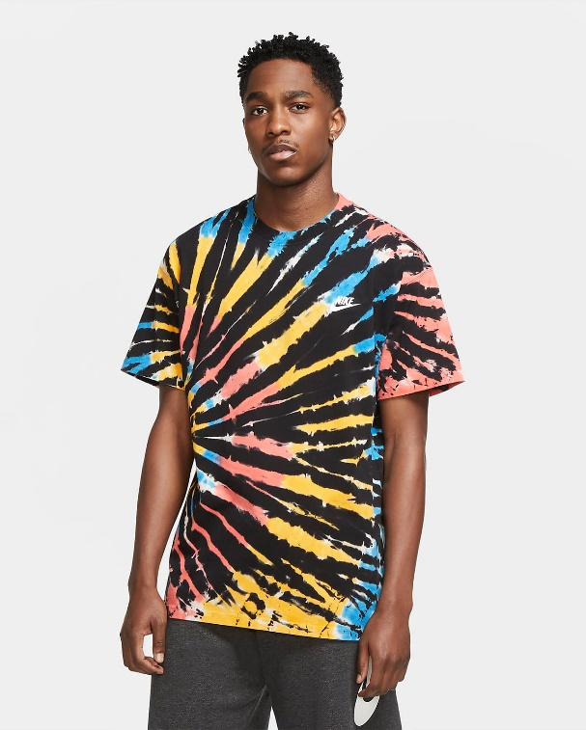Mallam Abubakar runs a family business specializing in tie and dye, and leather work. He attends tradeshows to be able to exhibit his products to wider audience. He is very interested in the membership of this organization and eagerly wants to advertise on the chamber’s website. He will regularly use the website to find prospective client for his products.

* Persona Category: individual
* Fictional name: Mallam Abubakar Umar
* Occupation: Leather work, Tie & Dye
* Demographics:
* Age: 35 Years,
* Qualification: Bachelor’s degree,
* Family Status: Married with 3 Children
* Job descriptions: CEO, Umar and Sons Nigeria Ltd

A summary quote: "Failures are expected by losers, ignored by winners".

**Site Map**:

*The site map is a sketch of all the website pages and references. It should illustrate the relationship between those pages*.

HOME

DIRECTORY

NEWS

ABOUT ACCI

JOIN NOW

CONTACT US

**Color Scheme**:

*The color scheme refers to the carefully selected site colors that reflect the organization's purpose and trademark colors. Note the organization does not have established colors for brand identity. The planning document defines the color scheme through a color palette that labels color style definitions and swatches for site elements.*

**Typography:**

*The project specifications require that you utilize the directory of open source designer web fonts provided by Google Fonts. The typography section of the planning document provides examples of the fonts to be used and where they are to be applied.*

## My Typography

Typography is so much more than just choosing beautiful fonts: it's a vital component of user interface design. Good typography will establish a strong visual hierarchy, provide a graphic balance to the website, and set the product's overall tone.

It tells the consumer what they're reading and why it's important to them. Typography influences how readers process information, and the most successful typography also engages the consumer.

## Font family

"Sansita", Ubuntu, sans-serif;

## Heading Font: "Ubuntu"

### Why Ubuntu Font?

The new Ubuntu Font Family was started to enable the personality of Ubuntu to be seen and felt in every menu, button and dialog. The typeface is sans-serif, uses OpenType features and is manually hinted for clarity on desktop and mobile computing screens.

## Paragraph Font: "Lato"

### Why Choose Lato font?

Lato is a sans serif typeface family started in the summer of 2010 by Warsaw-based designer Łukasz Dziedzic (“Lato” means “Summer” in Polish). ... In the last ten or so years, during which Łukasz has been designing type, most of his projects were rooted in a particular design task that he needed to solve.

## Normal paragraph example

It is a long established fact that a reader will be distracted by the readable content of a page when looking at its layout. The point of using Lorem Ipsum is that it has a more-or-less normal distribution of letters, as opposed to using 'Content here, content here', making it look like readable English. Many desktop publishing packages and web page editors now use Lorem Ipsum as their default model text, and a search for 'lorem ipsum' will uncover many web sites still in their infancy. Various versions have evolved over the years, sometimes by accident, sometimes on purpose (injected humour and the like).

## Colored paragraph example

Lorem Ipsum is simply dummy text of the printing and typesetting industry. Lorem Ipsum has been the industry's standard dummy text ever since the 1500s, when an unknown printer took a galley of type and scrambled it to make a type specimen book. It has survived not only five centuries, but also the leap into electronic typesetting, remaining essentially unchanged. It was popularised in the 1960s with the release of Letraset sheets containing Lorem Ipsum passages, and more recently with desktop publishing software like Aldus PageMaker including versions of Lorem Ipsum.

**Wireframe Sketches:**

*Produce wireframe sketches of at least the home page of the site design considering the purpose, specifications, and target audience. You should include sketches for small, medium, and large views respectively.*

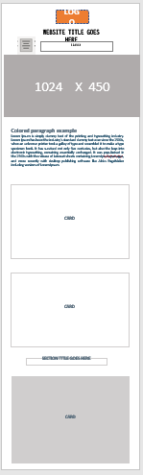Large width monitors Medium Small

